**Describe the purpose of the programming languages**

* 1. **HTML**

To develop and make websites

* 1. **Python**

To make and develop applications to solve a problem

1. **A line of *pseudocode* is as follows:**

**SET scores TO [63, 128, 89, 72, 51, 90, 68, 84, 83, 71]**

**State the most suitable *data structure* and *data type* for storing the variable scores**

Data structure: list

Data type: string

1. **State three ways in which a programmer can make their program code more *readable* to make future maintenance of the program easier.**
2. Spaces between assignment sign
3. Skipping a line between all assignments and functions, selections and/or loop
4. Have all imported libraries stated at the top of the program
5. **A programmer *compiles* their program before executing (running) it.** 
   1. **Explain the term *compiles*.**

When computers convert high level code into lower level code and into machine language (0s and 1s) that the computer can interpret and carry out.

* 1. **State where the compiled program is held while it is being executed.**

In the Random Access Memory (RAM)

* 1. **Using your answer to b), explain why the amount of main memory in a computer can be important when deciding on a computer system.**

The amount of main memory can decide many processes you can run on your computer. With more memory, you can run more and more intensive tasks.

* 1. **Describe an alternative method of executing a program.**

1. **A line of *pseudocode* is as follows:**

SET lightOn TO true

**State the most suitable *data type* for storing lightOn**

Boolean

1. **A line of *pseudocode is as follows:***

SET cost TO 629.99

**State the most suitable *data type* for storing cost**

Float

1. **A line of *pseudocode is as follows:***

SET address TO “16 Duddingston Road”

**State the most suitable *data type* for storing address**

String

1. **A line of *pseudocode is as follows:***

SET keyDown TO “S”

State the most suitable *data type* for storing **keyDown**

String

1. ***Pseudocode* is a text-based design notation.** 
   1. **Name and describe a *graphical* design notation. *(See questions 23 and 24)***

Flowcharts

* 1. **Give one advantage and one disadvantage of pseudocode over a graphical design notation.**

**Advantage:** can be written quickly in a word processor, saves time

**Disadvantage:** does not provide as good of a structure for programmers to read

1. ***Input validation* is to be carried out on data in the range -25 to 25 inclusive.** 
   1. **Give examples of three types of *test data* that should be used.**
2. -20
3. -50
4. 25
   1. **Explain why a program should be tested as comprehensively as possible.**

Programs should be comprehensively and thoroughly be tested in order to avoid any bugs or errors from happening which could cause users to be unsatisfied with the program. As more users encounter problems, the programs userbase would decline. Also, time, money and resources can be wasted in fixing the programs errors when found later on.

1. **State the type of programming construct(s) in each of the following cases:**
   1. **SET runningTotal TO 0**

variables

* 1. **IF coreTemperature >= 50 THEN SEND [“Alert!!”] TO DISPLAY**

Selection, built-in function, comparison

* 1. **FOR counter = 1 to 1000 DO**

loop

* 1. **REPEAT … UNTIL reading < 0**

Loop, comparison

* 1. **RECEIVE countryName FROM KEYBOARD**

Built-in function, variable

1. **Using *pseudocode* or a language of your choice, show how to validate** 
   1. **an age in the range over 20 and less than 66**

IF age > 20 and age < 66

* 1. **a price in the range 1.99 to 25.99 inclusive**

IF price >= 1.99 and price <= 25.99

* 1. **a character as being “X”, “Y” or “Z”**

IF character == “X” or “Y” or “Z”

* 1. **a name as being between 1 and 10 characters long (inclusive)**

IF len(name) is >= 1 and len(name) <= 10

1. **Using *pseudocode* or a language of our choice, show how to find the** 
   1. **average of 365 temperatures held in an array of real numbers called temperature.**

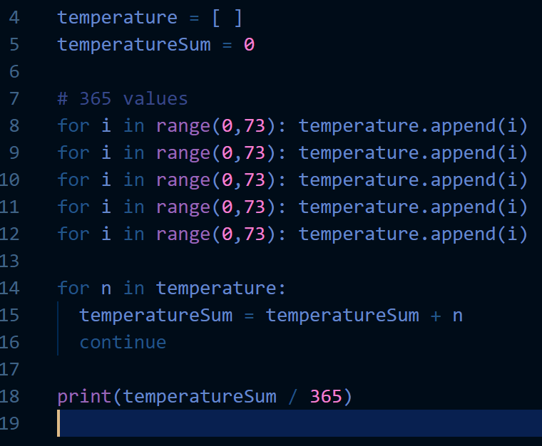

* 1. **average number of sheep in 1000 herds of sheep. The data is held in an array of integers called numberInHerd.**

SET numerInHerd TO a list of 1000 integers

sum = 0

REPEAT

<find sum of all integers>

END LOOP

avg = sum / 1000

SEND avg TO display

* 1. **average amount spent on food per week over 52 weeks. The amount per week is entered by the user.**

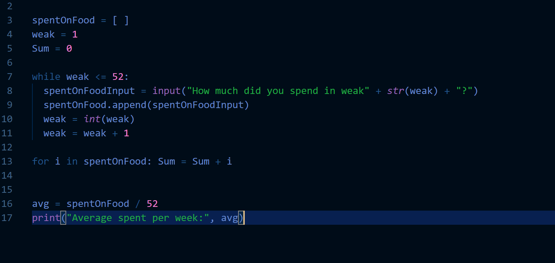

1. **The types of errors that can occur when programming are: *syntax, logic* and *system/runtime.***

**Identify the type of error**

* 1. **trying to divide by zero and making the program crash**

runtime error

* 1. **making a spelling mistake**

synatx

* 1. **IF (groupNumber > 1) OR (groupNumber <10) THEN…**

logic

1. **Expressions can be *logical* or *arithmetic.* State the type of expression used in each of the following:**
   1. **3+14/5**

arithmetic

* 1. **(time >60) AND (time <120)**

logical

1. **A program uses the *pre-defined functions* INT and RANDOM. Give two other pre-defined functions usually available to programmers.**
2. str
3. append
4. **A program is written to allow the user 3 attempts to enter a password into a secure banking website. After 3 failed attempts, the user sees the message “Please contact the bank directly”.**

**Here is the pseudocode for the program:**

Line 1. SET attempts TO 0

Line 2. REPEAT

Line 3. SET attempts to attempts + 1

Line 4. RECEIVE password FROM KEYBOARD

Line 5. IF (password <> correctPassword) THEN

Line 6. SEND [“Incorrect password”] TO DISPLAY

Line 7. END IF

Line 8. UNTIL ( __**password == correctPassword**___) OR (__**attempts == 3**____)

Line 9. IF (___**attempts == 3**_____) THEN

Line 10. SEND [“Please contact the bank directly”] TO DISPLAY

Line 11. ELSE

Line 12. SEND [“Welcome to the bank”] TO DISPLAY

Line 13. END IF

* 1. **Complete lines 8 and 9 of the pseudocode.**
  2. **Line 9 is necessary for the program to know why the REPEAT…UNTIL loop (lines 2-8) has stopped. Explain why this REPEAT…UNTIL loop is a *conditional* loop rather than a *fixed* loop.**

The program needs to know when to stop the loop, otherwise it may keep on going even after more than 3 attemps.

* 1. **State the type of construct used in line5-7.**

Selection

* 1. **State the type of construct used in lines 1 and 3.**

variable

1. The program below is designed to alert the driver of a car if the total distance driven is over 100 miles or the fuel quantity they have remaining is at most 5 litres. Complete Line 6.

Line 1. REPEAT

Line 2. RECEIVE distance FROM SENSOR

Line 3. RECEIVE fuel_used FROM SENSOR

Line 4. SET total_fuel TO total_fuel + fuel_used

Line 5. SET total_distance TO total_distance + distance

Line 6. IF _______**total_distance > 100 or total_<= 5**______THEN

Line 7. SEND [“Alert”] TO OUTPUT DEVICE

Line 8. END IF

Line 9. UNTIL <*journey’s end>*

1. **Explain clearly, with reference to variables and values, what the following pseudocode does**.

Line 1. SET validLength TO 10

Line 2. RECEIVE phoneNumber FROM KEYPAD

Line 3. SET thisLength TO length(phoneNumber)

Line 4. IF thisLength < validLength THEN

Line 5. SEND [“Invalid phone number – please re-enter”] TO DISPLAY

Line 6. ELSE

Line 7. SEND [“Phone number accepted”] TO DISPLAY

Line 8. END IF

The program validates whether a phone number is valid or not. This is done by checking whether the phone number is its correct length, 10 digits. The user enters a phone number into the variable, phoneNumber. The length of this variable is compared with the length of a valid phone number stored in validLength. The program outputs whether the phone number is invalid or is accepted.

1. **A program is required to display a weather warning if the wind speed is at least 80 mph or the temperature is below 0⁰C**

**Here is the pseudocode for the program**:

Line 1. RECEIVE windSpeed FROM SENSOR

Line 2. RECEIVE temperature FROM SENSOR

Line 3. IF (windSpeed > 80) AND (temperature <0) THEN

Line 4. SEND [“Weather warning”] TO DISPLAY

Line 5. END IF

* 1. **Identify two logic errors in the pseudocode above.**
  2. **Identify *test data* that should be used to test this code, stating whether piece of test data is *normal, extreme* or *exceptional* data.**

Windspeed=80: extreme, windspeed=75: exceptional, windspeed=90: normal

Temperature=-1: extreme, temperature= data: exceptional, temperature= -5: normal

* 1. **State the hardware required to connect the sensors to the computer system to allow transmission of the data.**

Micro-controller

1. **a) Explain clearly, with reference to variables and values, what the following pseudocode does.**

**b) Line 10 could give a runtime error. Explain under what circumstances this could happen and change the line to correct the error.**

The loop will never stop running as the loop will only stop if plantHeight is less than one, with the above lines, this is impossible.

Line 1. SET total TO 0

Line 2. SET counter TO 0

Line 3. REPEAT

Line 4. RECEIVE plantHeight FROM SENSOR

Line 5. IF plantHeight > 2.5 THEN

Line 6. SET total TO total + plantHeight

Line 7. SET counter TO counter + 1

Line 8. END IF

Line 9. UNTIL plantHeight < 0

Line 10. SEND [“Average: ”, total/counter] TO DISPLAY



1. A programming language provides the following built-in functions:

**move n**  n = distance moved in pixels

**turn d** d = degrees turned (positive means clockwise)

**pen_down()** drawing starts

**pen_up()** drawing ends

**These can be used by the programmer to draw lines.**

* 1. **The following program was written to draw the shape shown. Assuming the initial move direction is up the screen, one of the lines has an error. Identify the error and give the correct line.**

turn 90

move 50

turn 90

move 75

turn 90

move 50

pen_up()

move 20

pen_down()

move 50

* 1. **Write a program to draw the following shape. The arrow shows the start position and direction:**
  2. **Draw the shape that results from the code shown below:**

REPEAT 4 TIMES

pen_down()

turn -90

move 70

right 90

move 40

pen_up()

move 10

END REPEAT

1. **Below is a structure diagram for a program to display the percentage discount on a theatre ticket. Write the corresponding program in pseudocode or in a programming language of your choice**

Problem:

Calculate percentage discount

Is age > 15?

Display

percentage discount

Get age of customer

No

Yes

percentage discount = 0.20

Is age > 60?

No

Yes

percentage discount = 0.05

percentage discount = 0.50

RECEIVE age

IF age > 15

IF age > 60

DISPLAY “percentage discount = 0.50”

DISPLAY “percentage discount = 0.05”

ELSE

DISPLAY “percentage discount=0.20”

1. a) Draw a *flowchart* as the program design for a program to find the average of 10 heights.

Start: Average of ten heights

True

Heights = [ ]

Count = 0

userHeightInput = 0

Get user inputted height from user, append to heights

Count + count +1

While count <= 10

False

Find the sum of height using the sum function

Avg = sumofheights / 10

Display avg

1. Write the equivalent pseudocode.

SET heights TO [ ]

SET heightInput TO 0

REPEAT

RECEIVE heightInput FROM KEYBOARD

<convert heightInput to the float type>

<use the append function to add the input onto the heights[] variable>

Count = count + 1

UNTIL count = 10

sumOfHeights = sum(heights)

avg = sumOfHeights / 10

SEND avg TO DISPLAY